**Hotel Booking Management Database System (HBMDS)**

**Usage Documentation**

**Overview**

The Hotel Booking Management Database System (HBMDS) is one of the integral tools in hotel booking management. This document offers step-by-step usage of the system by explaining all the major functionalities, navigations, and operational procedures.

**System Requirements**

* **Operating System**: Windows 10 or later, macOS, Linux
* **Web Browser**: Google Chrome, Mozilla Firefox, Microsoft Edge
* **Database**: MySQL, PostgreSQL, or any SQL-compatible database
* **Internet Connection**: Required for online features and updates

**Logging In**

1. **Access the System**:
   * Open your web browser and navigate to the HBMDS URL (e.g., https://yourhotel.hbmds.com).
2. **Login Credentials**:
   * Enter your username and password provided by the system administrator.
   * Click the "Login" button.
3. **Forgot Password**:
   * Click on the "Forgot Password" link if you need to reset your password.
   * Follow the instructions to reset your password via email.

**Dashboard**

Upon logging in, you will be directed to the dashboard, which provides an overview of hotel operations.

1. **Navigation Menu**:
   * **Customer Registration**: Registration for the customer. It shows it by customer phone number.
   * **Booking**: Booking information with the room number and hotel.
   * **Payment Information**: Show the payment method with the booking number.
   * **New Hire**: It shows the employee registration ID.
   * **Worker Information**: Shows the worker ID and employee ID.
   * **Promotion**: shows Manager ID and Employee ID.
   * **Customer Information**: Show the history of the customer’s booking by customer’s phone number
2. **Menu**
   * **Customer Registration**
     1. Navigate to Search icon
     2. Enter customer’s phone number
     3. Return customer's information

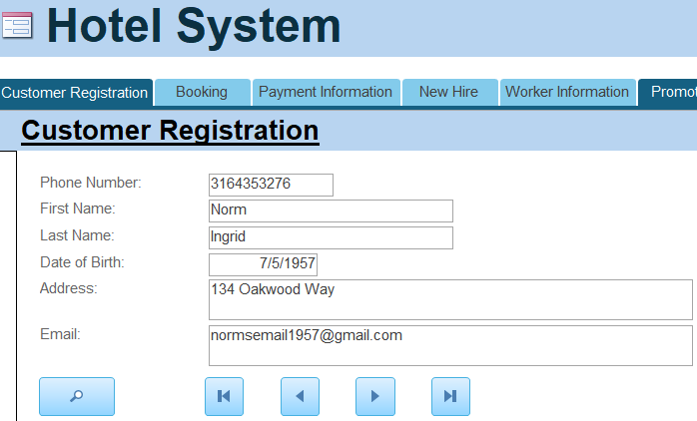

* **Booking**
  + 1. Navigate to Seach icon
    2. Enter Booking ID or customer’s phone number
    3. Return the booking ID and shows the information about the room, hotel address, Check in and Check out date.

* **Payment Information**
  1. Navigate to Seach icon
  2. Enter Payment ID or Booking ID
  3. Return the Payment ID and Booking ID
  4. Shows the Invoice price, Invoice Date, and Payment Method.

* **New Hire**
  + 1. Navigate to Seach icon
    2. Enter Employee ID or Phone number
    3. Return the Employee New ID, the Hotel address for work, Employee’s first name and last name, Date of Birth, and Phone number.

* **Worker Information**
  1. Navigate to Seach icon
  2. Enter Employee ID
  3. Return the Woker ID and Position at work.

* **Promotion**
  1. Navigate to Seach icon
  2. Enter Manager ID or Employee ID
  3. Return the Department.

**Customer Information Report**

This shows the customer’s history of bookings with our HBMDS. HBMDS can track the customer’s past booking history with the customer’s information, Room Number, date when they visited.

**Conclusion**

The HBMDS is a feature-rich tool designed to deriving efficient and effective hotel operations. Through this usage documentation, hotel staff will be better placed to fully tap into the power of HBMDS for top-notch hospitality and booking management services, and the optimization of overall hotel management.